

MEltdown attack

SEED LABS



October 14, 2019

Dhaval Sonavaria

272252089

**Task 1: Reading from Cache versus from Memory**

We compile and run the code CacheTime.c to print out the access times of the blocks of data that we first created.

* We first initialize an array with a size similar to 10 blocks of data.
* We then flush this array from the cache so that the next access leads to a memory fetch
* We access block 3 and 7 so that they are now present in the cache after a fetch
* We now print the time take in CPU cycles to access all the 10 blocks of the array.

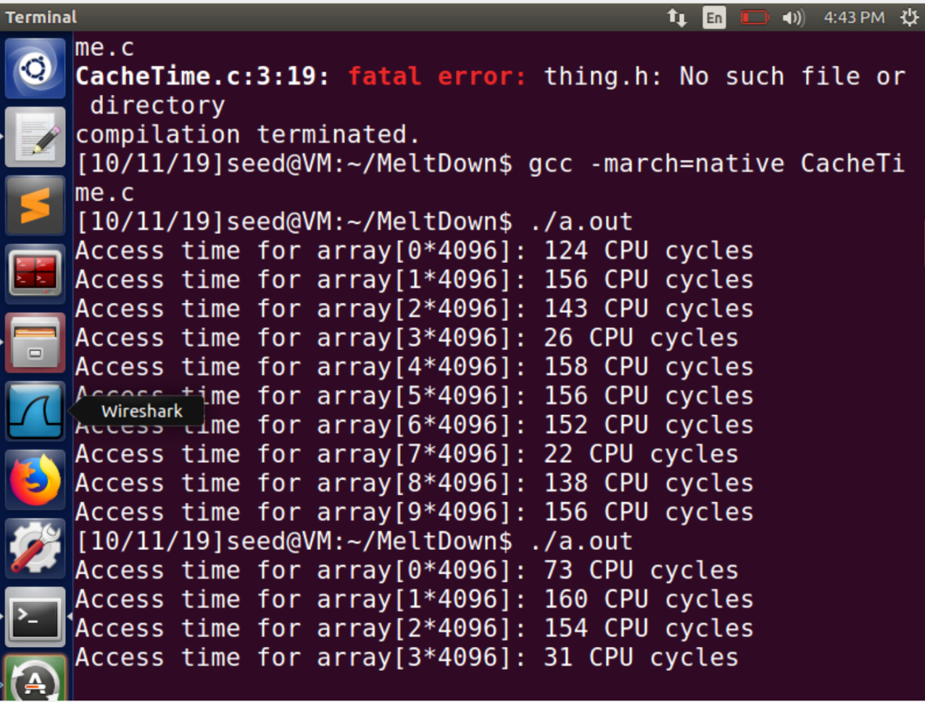

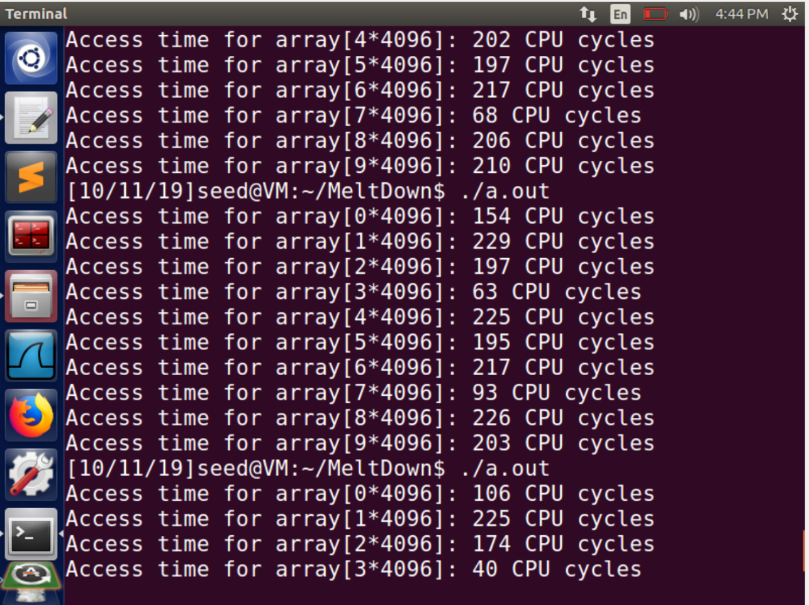

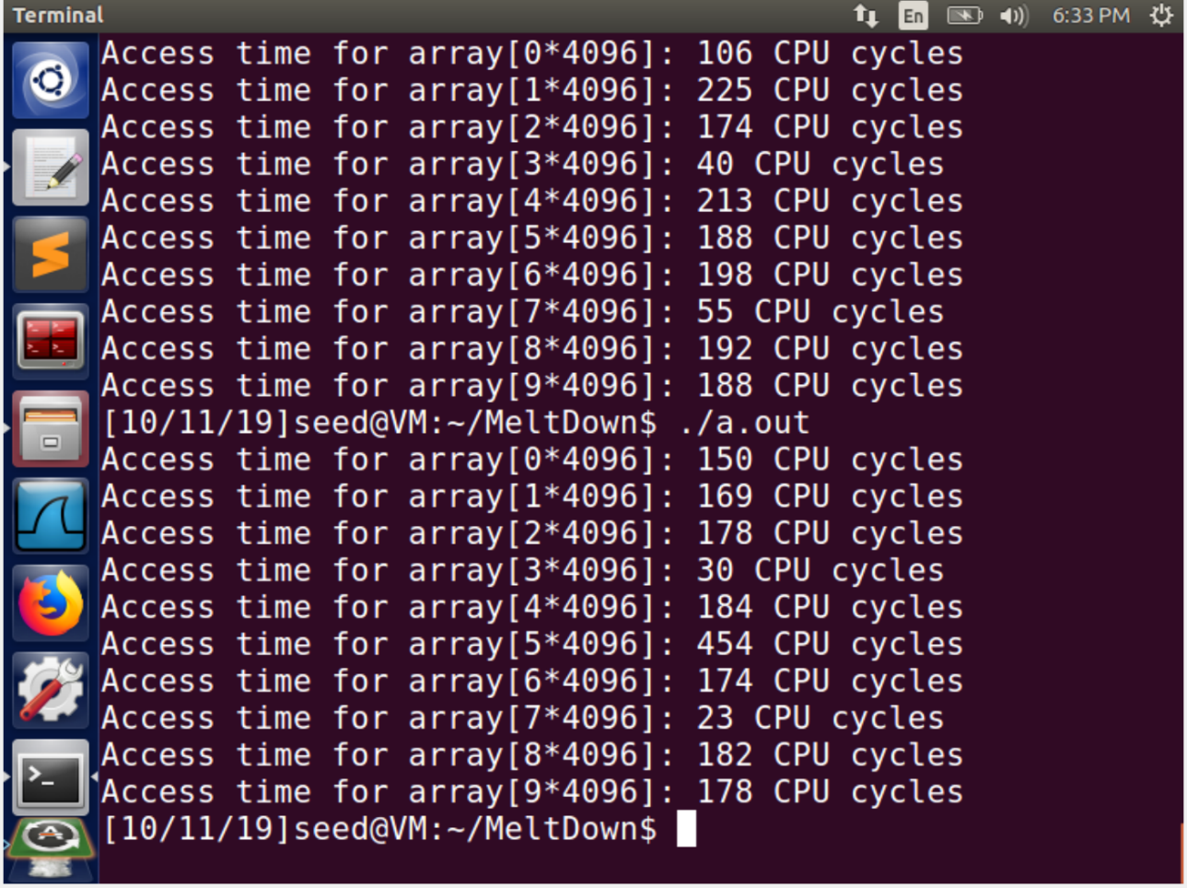

We can see that the blocks 3 and 7 of the array have drastically low access time since they were present in the cache. After performing the experiment 10 times, I noticed the blocks present in the cache did not have an access time higher than 80 CPU cycles. We will set thus as our threshold to distinguish if the block of data was present in the cache before access or not.

**Task 2: Using Cache as a Side Channel**

In the previous task we showed the difference in access times between blocks of data present and absent in the cache.

We will now implement this knowledge and use it to decode a secret block of data that we accessed before. This kind of medium of decoding to know the data/information is known as side channel.

We use the

* FLUSH
* Access
* Decode

We first access the information from a separate function, we will then try to decode the information(block of data) that we accessed from a separate function but, before this we initialize and flush the stack to make sure that it is empty.

We initialize a 256*4096 +Delta[1024] size of array, since we can represent 28 different values using a byte. Adding the Delta makes sure that we access somewhere in middle of the block of data and not in an intersection between two blocks, making our side channel more easy to decode.

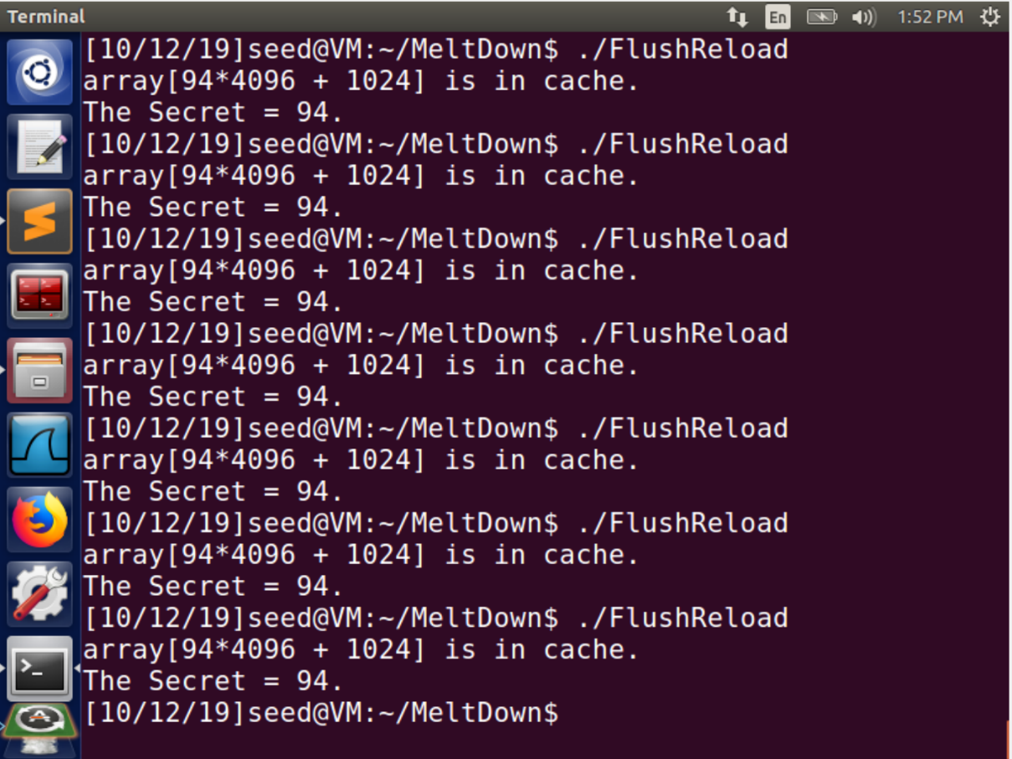

As we can see we made the function calls of flush(), victim()[Access], reloadSideChannel() to decode the secret variable(94) accessed from the victim() function.

**Task 3: Place Secret Data in Kernel Space**

After gaining the knowledge of difference in access times between blocks of data present in the cache and absent and applying it to decode a secret. We will now try to perform this on kernel data.

To do this we will place the secret data in a kernel module and load it

* We also, access it once to make sure that the data is present in the cache
* We then print out the address to increase the odds of performing this attack

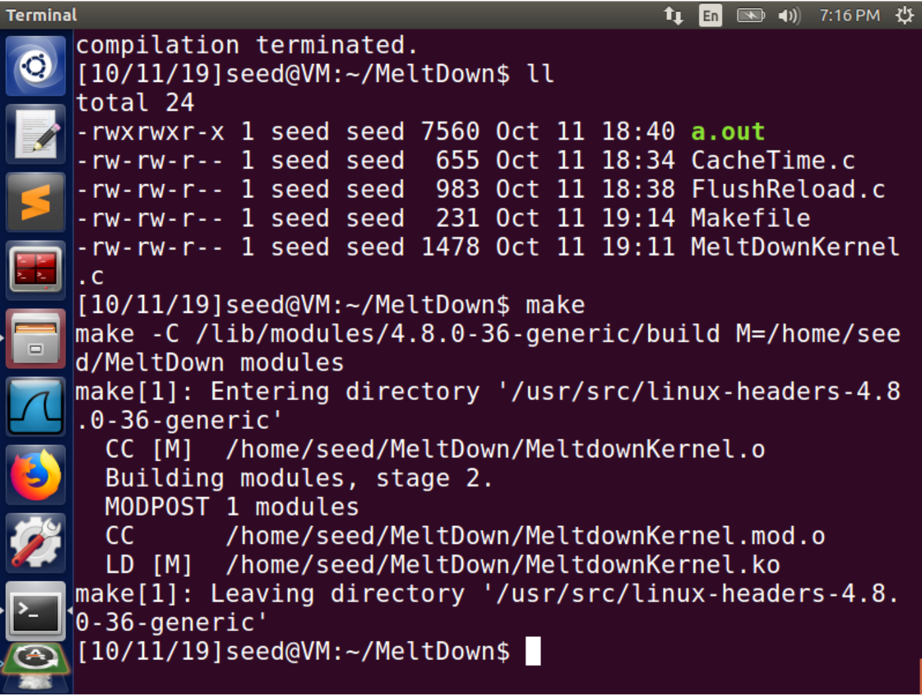

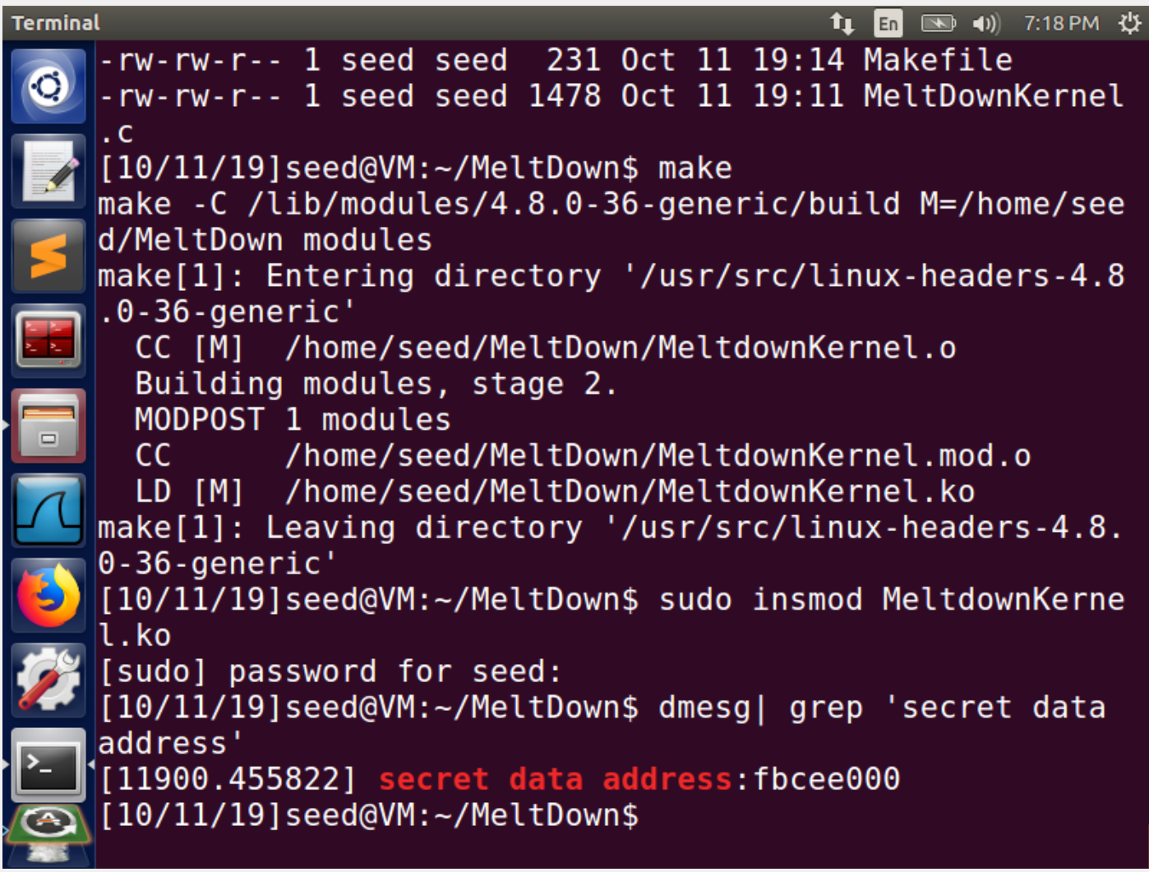

**Task 4: Access Kernel Memory from User Space**

Now that we have the kernel address, where the secret variable is stored and is present in the cache. We move on to check whether this data is accessible using a simple C program.

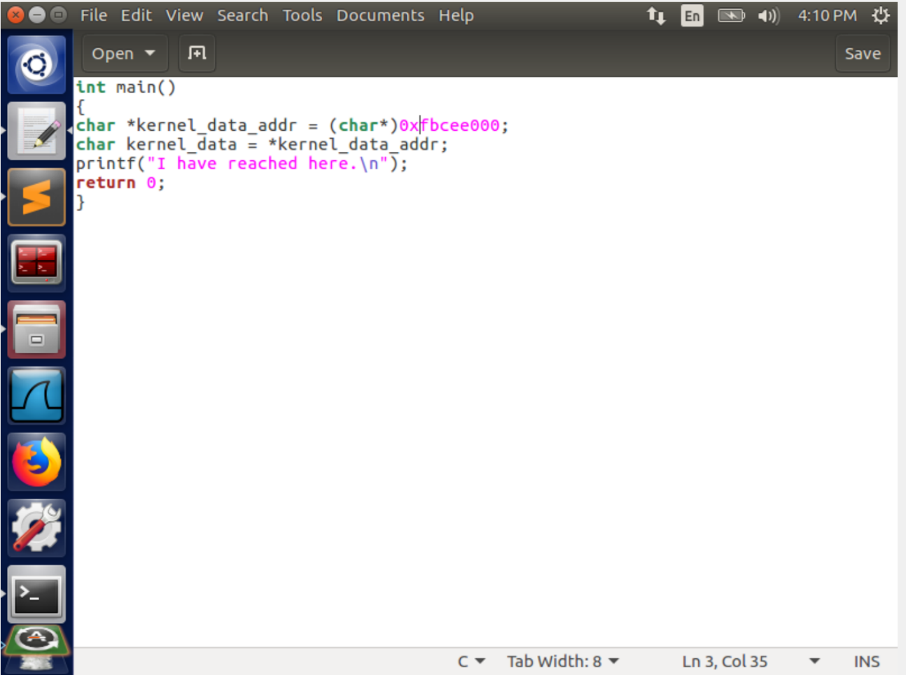

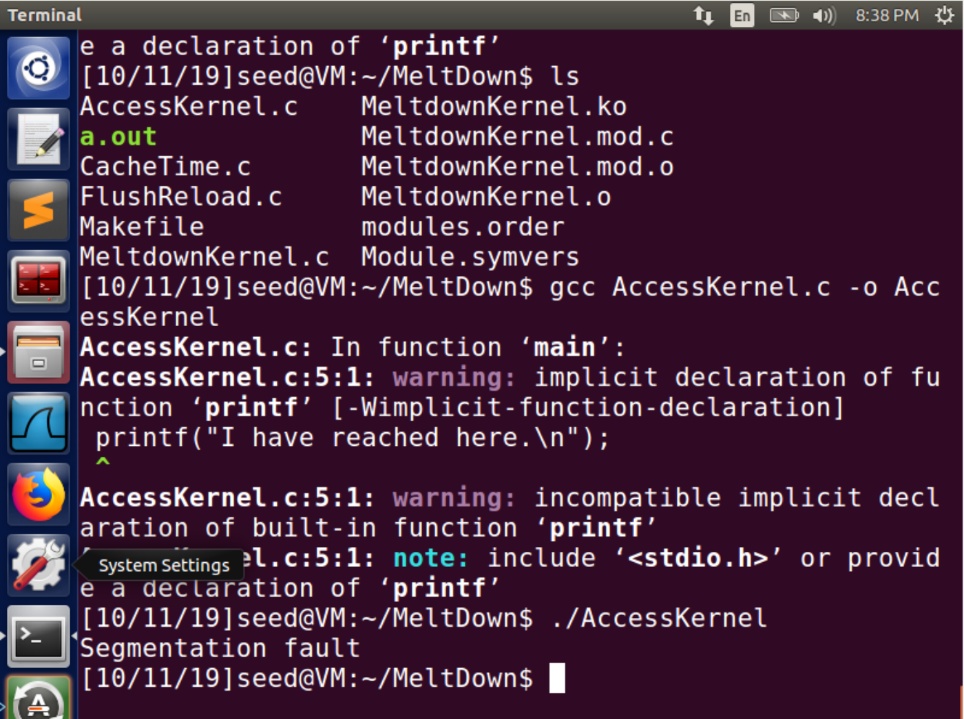

This causes a segmentation fault which is expected since this is a user program.

**Task 5: Handle Error/Exceptions in C**

Now, that we know the kernel address, and our access privileges to this address. We know that it will cause a segmentation fault, which will result in the program throwing an exception. Our goal is to perform some operation on this address and for this we must handle this exception thrown. Unfortunately, C does not provide try/catch blocks and we must set up a signal receiver to receive and handle this exception.

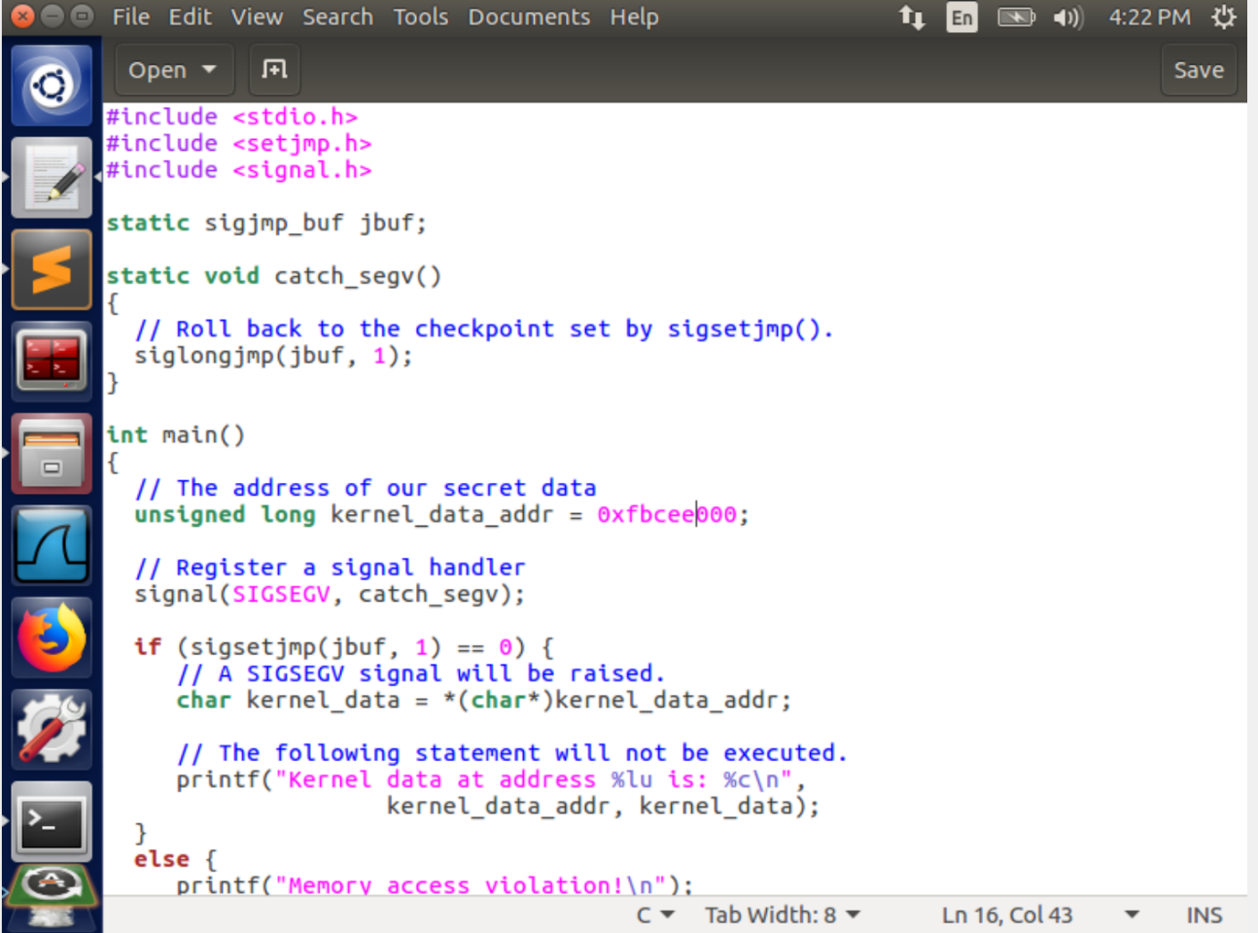

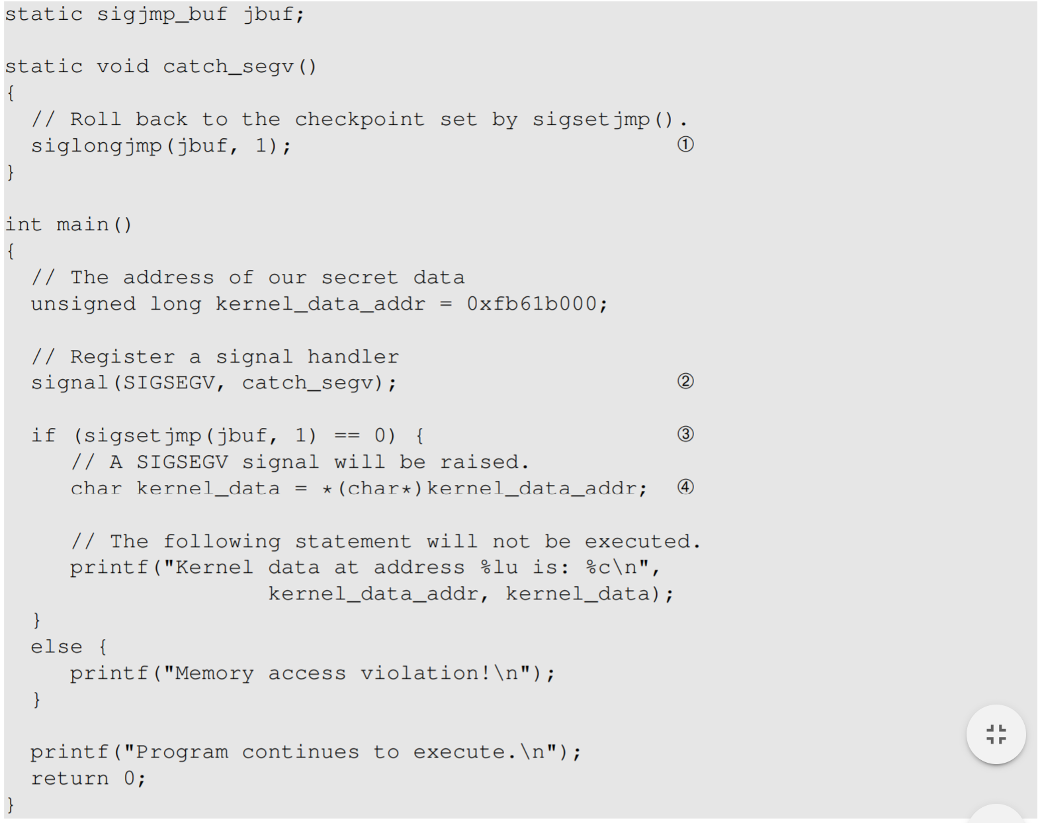

* We first set up a signal handler, so that when a SIGSEGV signal is raised we will be able to handle it using the catch_segv().
* We set up a check point, where the program will return after processing the exception. This is done by sigsetjmp(jbuf, 1) which returns 0 after the check point is set up.
* The siglongjmp(jbuf,1) saves the stack trace of the program in jbuf, so after execution we return at the breakpoint and can continue execution.
* The code at 4 will trigger the exception which is similar to the memory access violation we faced in the previous task.

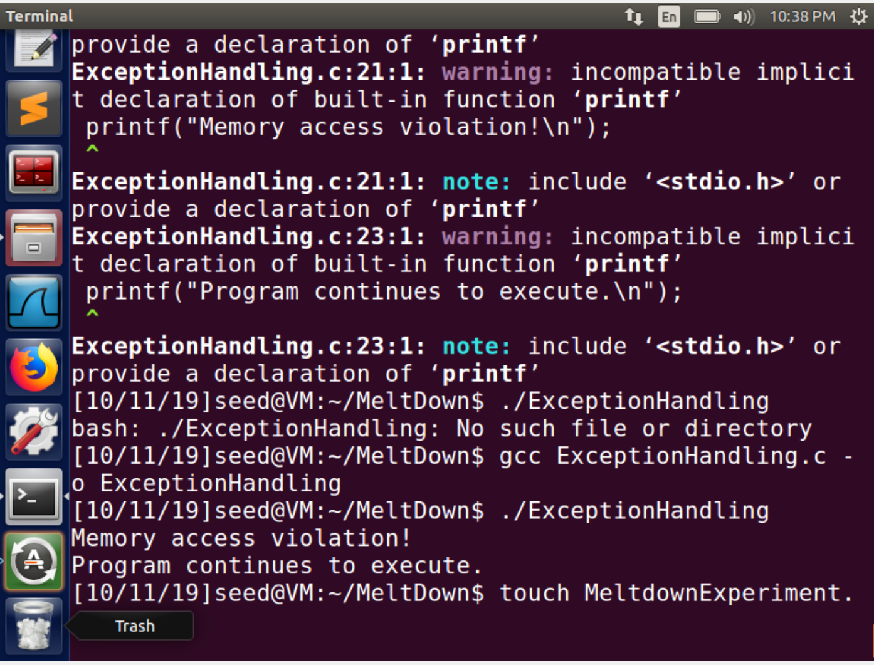

**Observation:**

We were successful in continuing the execution of our program, since the program did not crash when we accessed the kernel memory and continued execution as siglongjmp() sets sigsetjmp as 1 and the else branch is executed, while initially it was 0 which executed the if branch that caused the memory access violation.

**Task 6: Out-of-Order Execution by CPU**

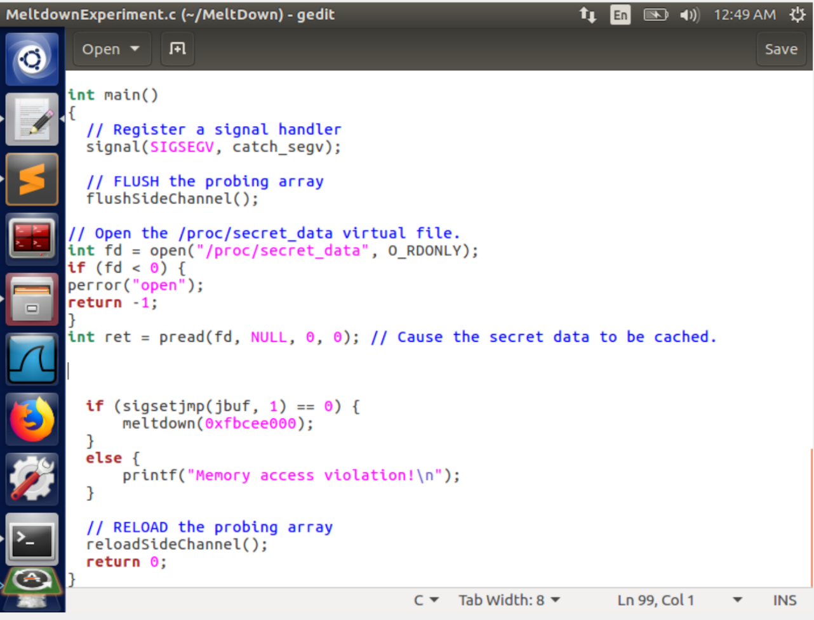

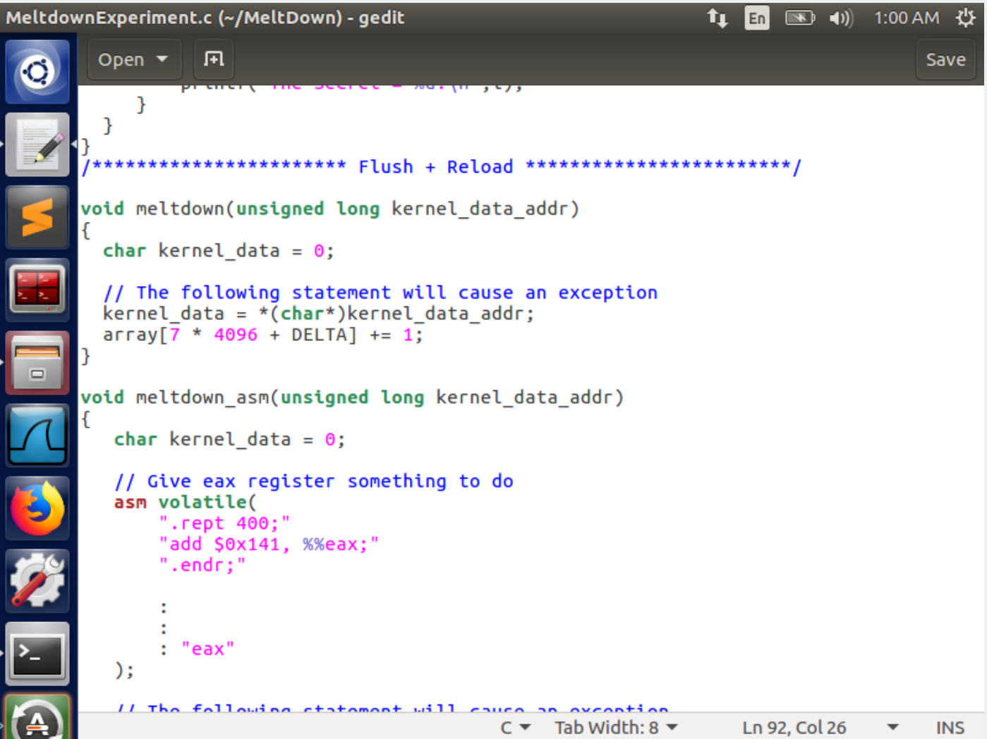

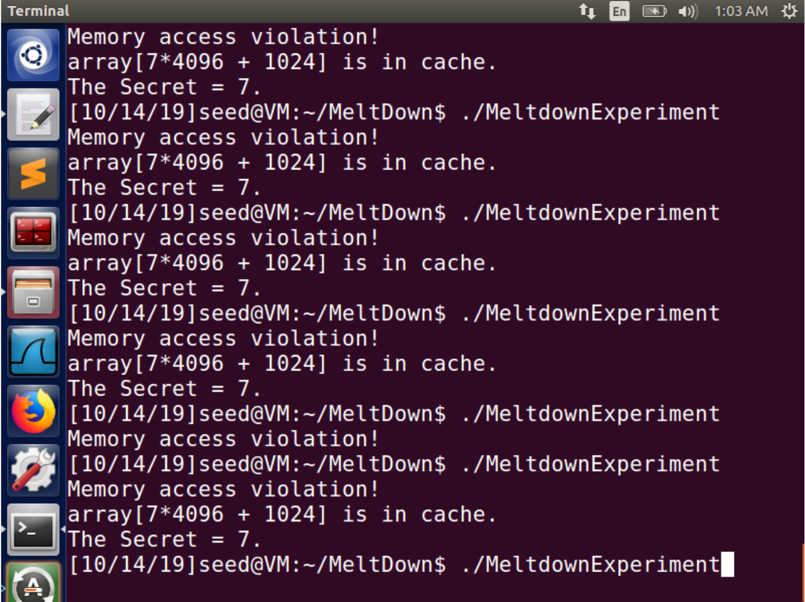

**Observation:**

Upon execution of meltdownexperiment.c we notice an inconsistent output of first a memory access violation! And then the secret accessed data (7) which means that 7 was accessed even though there was a memory access violation i.e the access check failed and our receiver handled an exception.

**Explanation:**

In this experirment, we used the knowledge gathered from all above tasks.

1. We first, bought all the blocks of data in RAM to prevent Copy on write and then flushed them from the cache.
2. Now we set up the signal handler to handle the memory access exception since we are about to access kernel memory.
3. Initially the if branch runs since the handler has not been triggered yet. As soon as we call meltdown() the handler is triggered due to the access check, but while the access check is taking place the CPU uses out-of-order execution and we access 7th block to disclose a secret. At this point, the handler is triggered and we return the execution using jbuf at the else branch which acknowledges a memory access violation has taken place. But till then we have already accessed the 7th block.
4. This is proved by the fact that we compare the access times of all the blocks and find out the 7th to have access time lower than the threshold accesss time(80)
5. As you can see this result is not consistent because sometimes the access check finishes before we actually access the 7th block.

**Task 7: The Basic Meltdown Attack**

In the previous task we accessed block 7 from the kernel stating that 7 was the secret inside the kernel. But this was something we passed just to check if we could win the race condition against the access check and execute some code that remained in the cache to then check our access CPU cycle method to gain this secret.

Now we will try to actually steal the secret which we stored at the beginning using the make file while installing the kernel module.

This is nothing but using the outputted address from the previous task and using to access the specific bit it represents in our 256*4096 block of array. In our case we stored SEED labs in the kernel module. S equates to 83 in ASCII. Our modification will be just to use the kernel_address passed to us by the attacking function instead of the inbuilt value we used before.

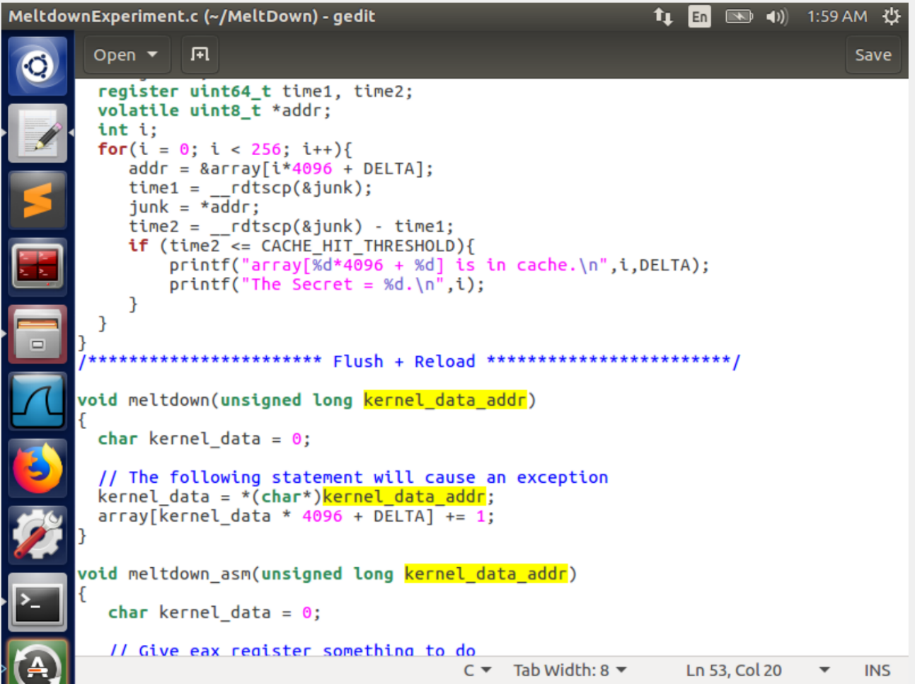

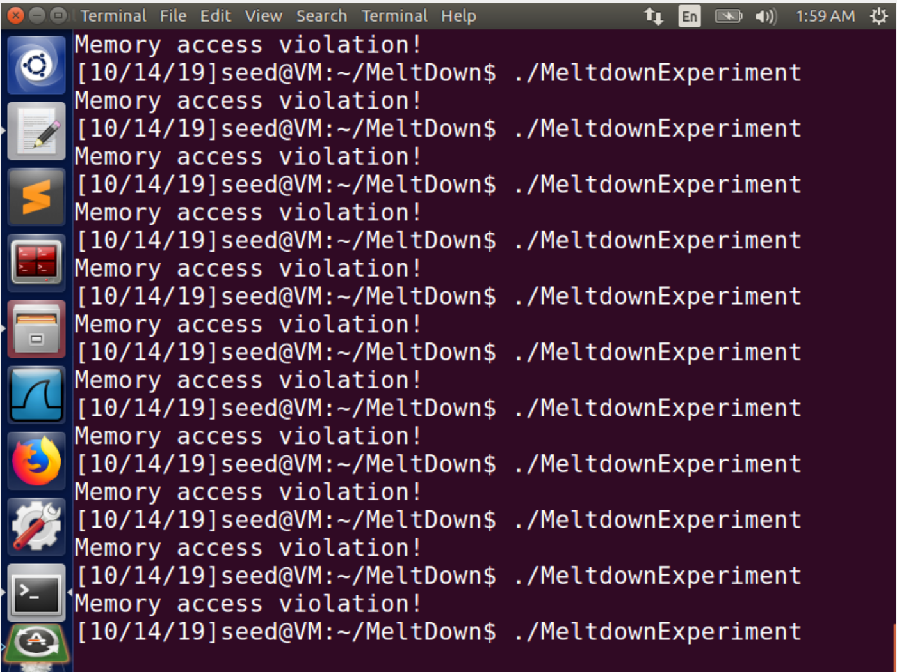

**Observation:**

We notice that this time there is only a memory access violation printed and no block of data was accessed.

**Explanation:**

This means that we failed to win the race condition against the access checker. The out of order execution could not be successful before the access check and we moved to the next branch after handling the exception.

To improve this attack we have to somehow increase this time taken by the CPU to check the access.

**Task 7.2: Improve the Attack by Getting the Secret Data Cached**

As noted previously we lost the race against the access check since our out of order execution took a lot of time. To counter this we implement the strategy of bringing in the kernel data to the cache so that we can reduce the time of executing our out of order execution.

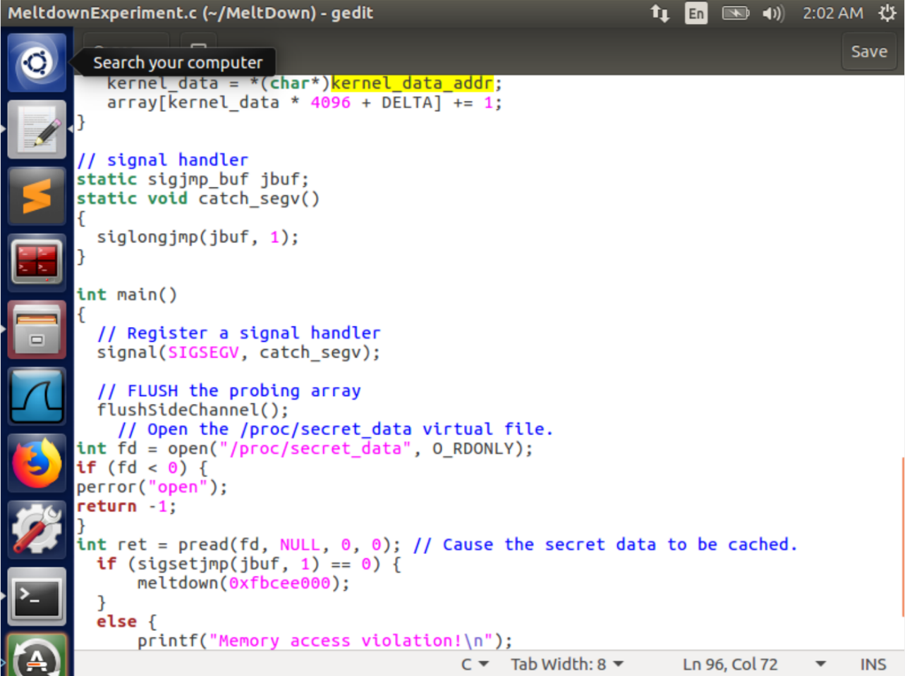

To bring in the kernel data in the cache we implement the proc we used in task3 that ran a function on the kernel module. This brings the data in the cache, placing this block of code between flush() and meltdown() makes sure that we still have the data in the cache.

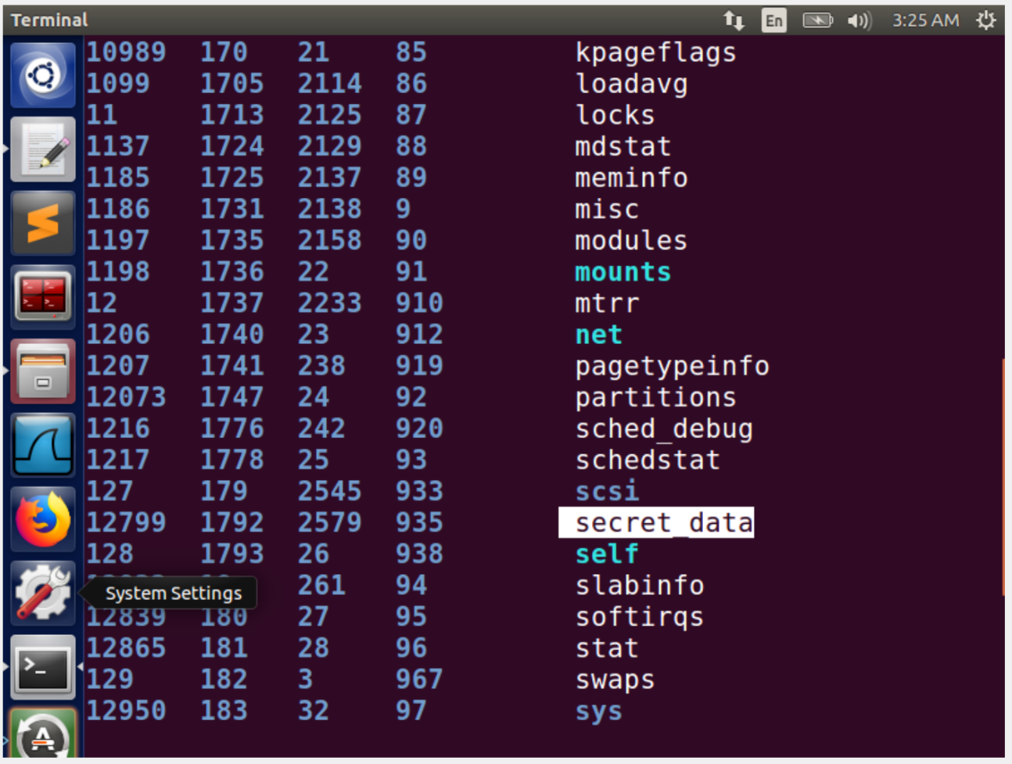

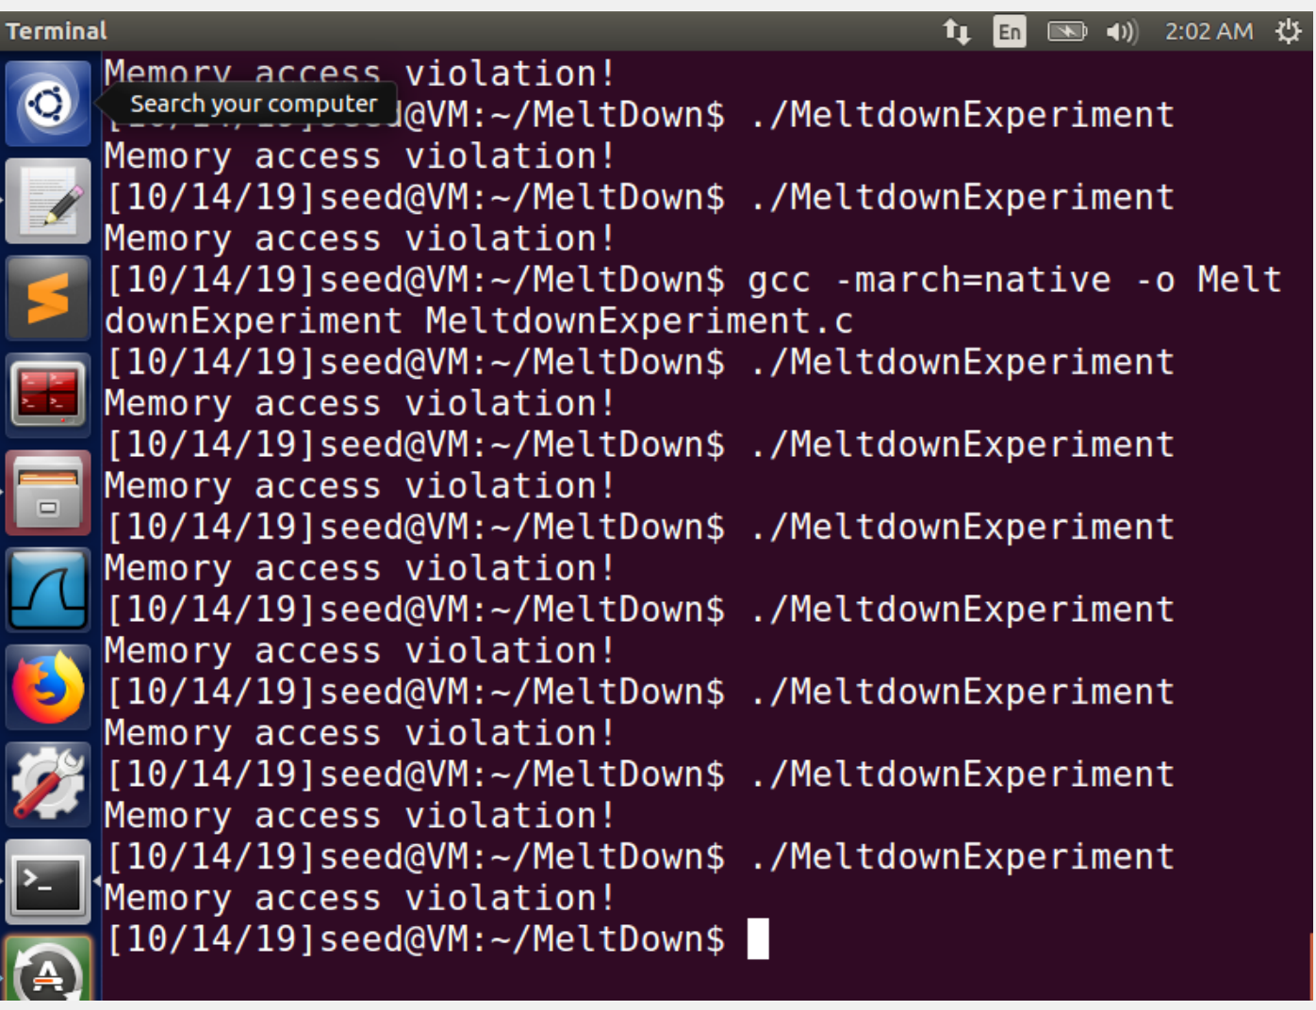

As we clearly see that doing so does not make a difference the access time is still to short and we cannot win the race against it. This approach was not successful because maybe it did not bother the access check time but instead tried to decrease the time to perform an operation on the kernel module data.

**Task 7.3: Using Assembly Code to Trigger Meltdown**

“give the algorithmic units something to chew while memory access is being speculated”

We now try to increase the actual time the CPU takes while checking. The hypothesis is that if we flood the eax register with a lot of instructions dependent on one another, this will internally put a load on the CPU thus increasing the time it needs to check the access, while it may not effect our aceessing the kernel data since it is cached and hence faster.

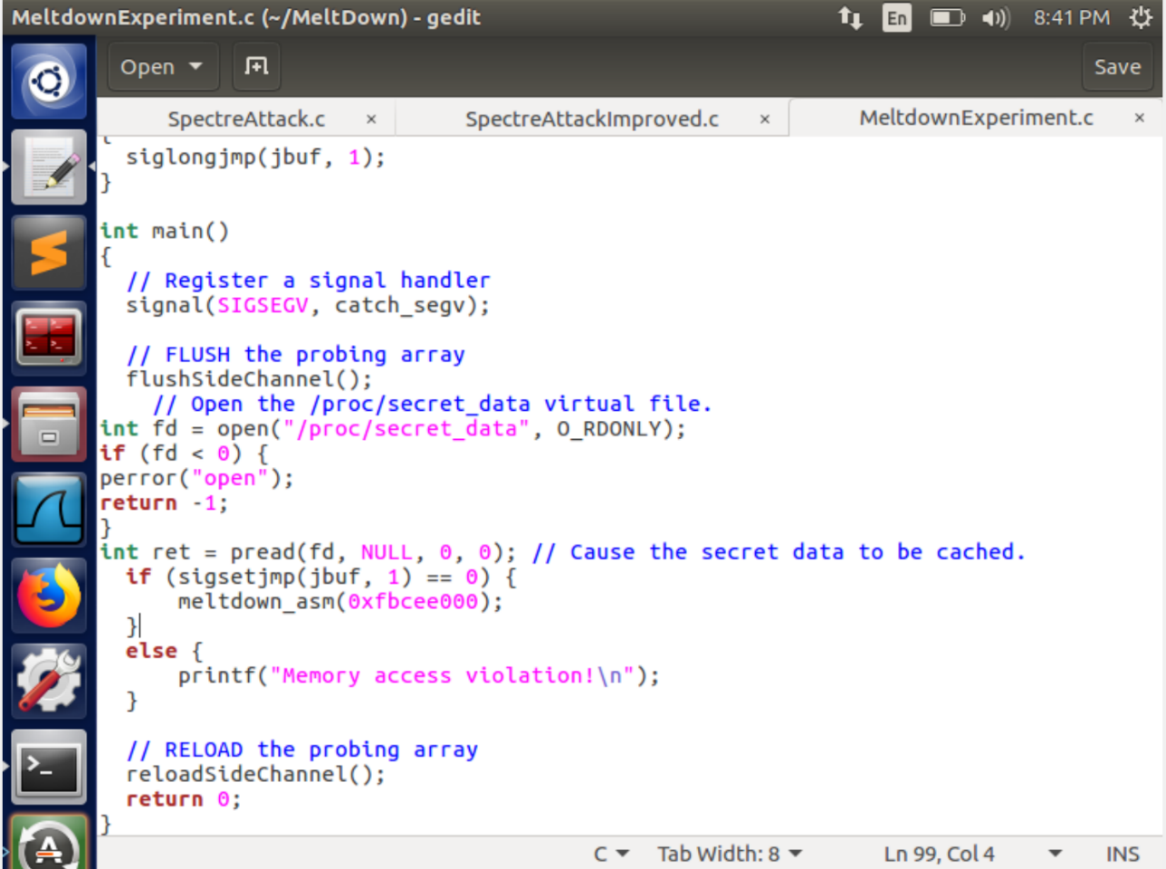

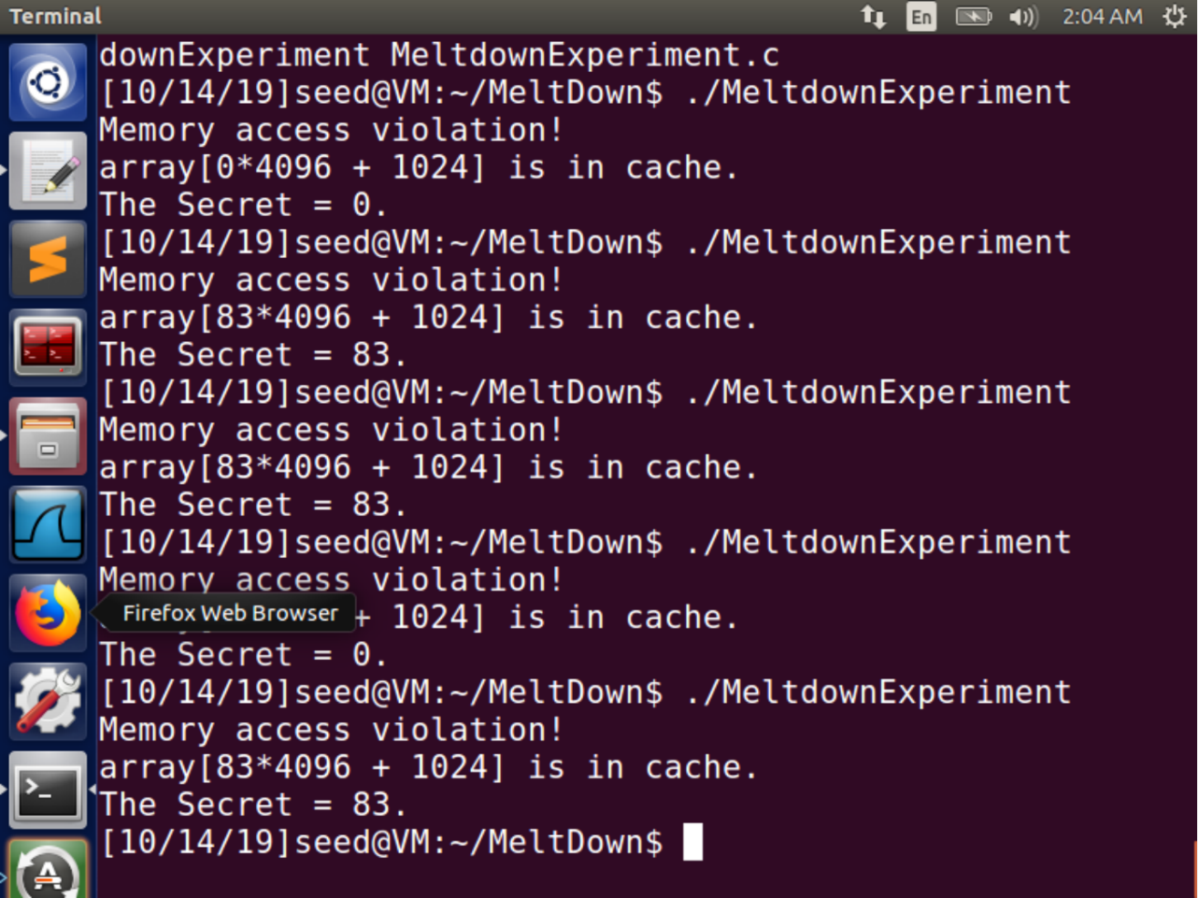

**Observation:**

The result is still not consistent giving an address fault sometimes , 0 as the answer and the correct answer sometimes.

**Task 8: Make the Attack More Practical**

This time to improve our side channel we make a bitmap kind of data structure that stores the scores of all 256 possible values and checks the highest score. This gives us a definite result and we can decode the secret

